Local Digital Skills Partnerships:

Information document for
Local Enterprise Partnerships (LEPs):

January 2018

1: Introduction:
In the Digital Strategy, published in March 2017, the Government set out its commitment to improving the digital skills capabilities of individuals and organisations across England. The digital skills gap, however, is not a problem that Government can tackle alone. That is why Government announced the formation of a Digital Skills Partnership (DSP) which will bring together the public, private and charity sectors and key regional stakeholders to develop a more collaborative, coordinated and innovative approach to meeting the digital skills challenge. To support the Digital Strategy, partners pledged more than 4 million digital skills training opportunities, symbolising the beginning of partnership working.
For the Digital Skills Partnership to be successful, it needs to have an impact at a local level. Local communities and regional stakeholders need to consider their local digital skills needs and draw up action plans to provide the skills and support needed locally. There is currently little consistency between regional initiatives, and efforts to increase digital skills for the benefit of local economies and communities are disjointed. Although there are some great examples of local good practice, very few look at digital skills across the spectrum.
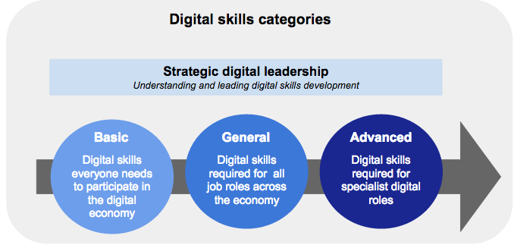There is a strong correlation between digital exclusion and other forms of exclusion (poverty, age, gender, disability, work status, education, and proximity to services). If left unchecked it is likely to exacerbate other forms of exclusion. Lack of basic digital skills and the ability to use the internet safely and securely is a key barrier to digital inclusion. 11.5 million people (over the age of 15) lack one or more of the five basic digital skills (Lloyds/Ipsos Mori 2017).
On advanced digital skills side it is estimated that 1.2 million new technical and digitally skilled people will be needed by 2022 to satisfy future skills needs. A more data-driven and action-focused local approach to tackling digital skills shortages will help drive the growth of local digital economies. It could provide more local employment opportunities by better matching demand and supply. Encouraging stronger partnerships between industry and schools/colleges, encouraging more innovative ways to fill local digital skills shortages and creating more diverse talent pools could also help to fill local talent shortages.
We are also living in a world where it is increasingly important to develop and maintain the general digital skills needed at work and to get the most out of a digital economy. The majority of the population sit in this big middle. And helping our small businesses and charities thrive in the digital world is also crucial to their success.
Local action can be a key driver: trusted faces in common places and joining up local organisations have been shown to have the most impact. There is an opportunity to ensure that different localities take advantage of innovations, data, evaluation and a broader evidence base by sharing and incentivising best practice. The Government therefore wants to incentivise and support the creation of Local Digital Skills Partnerships across the country - local partners coming together to look at how best to tackle local digital skills needs across the spectrum.
Importance of Local Enterprise Partnerships:
Local Enterprise Partnerships (LEPs), supported by key regional stakeholders, can play an important role in bringing together local partners so that silos are removed and there is a coherent and joined-up approach. LEPs are well placed to encourage and foster regional collaboration with these key stakeholders. The LEPs provide full geographical coverage of England, which gives the DSP reach to local organisations and delivery networks. (Digital skills and inclusion policy is devolved to the nations, but Government will share findings and best practice with Northern Ireland, Scotland and Wales).
2: Digital Skills Partnership, Board and Delivery Groups:
Government has previously used its convening power to bring partners together to tackle digital inclusion issues - for individuals and organisations - through the Council for Digital Inclusion. As set out above, it is crucial that we look at the digital skills needs across the spectrum. The Council has therefore been merged with the Digital Skills Partnership Board (List of DSP Board - Annex B).

The first DSP Board meeting, co-chaired by the then Minister for Digital, Matt Hancock (now Secretary of State), and Phil Smith, Chair of Cisco UK & Ireland, was held in November 2017. Twenty four organisations representing the public, private and charity sectors (including Google, Microsoft, BT, Barclays, Lloyds, AbilityNet, Good Things Foundation, Amazon Web Services, and Nominet, came together to start discussions on how best to collaborate to tackle the digital skills gap, including regionally.

In order to maximise impact, the DSP Board will focus on a set of clearly defined work-streams with members leading or co-leading or supporting Delivery Groups to drive forward action. These Groups will have representation from a wider range of partners to maximise diversity of thought, resources and experience. The four Delivery Groups that are currently being established are: the Local Digital Skills Partnership (LDSP) Delivery Group, National Coherence Delivery Group, Digital Enterprise group and Computing in Schools Delivery Group.
It is important to emphasise that the Digital Skills Partnership is not just comprised of the the DSP Board and the Delivery Groups - it is a partnership with a wide range of partners across the country who want to support this agenda. We also recognise the need to work collaboratively within Government. Over the last few months we have engaged with colleagues within DMCS and across other Government departments to raise awareness of the DSP and LDSPs and have explained how the DSP could be utilised in the delivery of numerous complementary digital skills initiatives currently being funded by a number of Government departments.

3. The Local DSP Delivery Group and developing best practice:
The Local DSP Delivery Group will be tasked to consider how we can better share and incentivise best practice at a local level so that supply can better meet the demand for advanced digital skills and and the needs relating to digital inclusion/basic digital skills and general digital skills for individuals and organisations can be better met/targeted.
In consultation with a wide range of stakeholders we have started to develop a basic 5-step model to support LDSPs. The Delivery Group in consultation with a wide range of stakeholders will further develop the framework and continue to iterate it. The immediate aim is to initially work intensively with two LEP regions to help shape its development.
Government will encourage other LEP regions to consider setting up and developing their own local digital skills partnerships and will seek to support this activity with the necessary partner support to help deliver digital skills training where needed.

The Local Digital Skills proposed Partnership model:

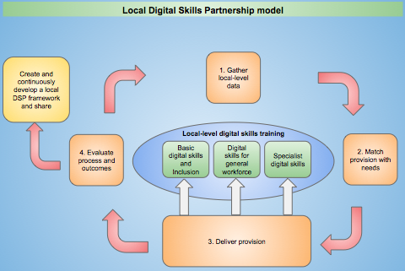

4. Incentivising and Supporting LDSPs
The Local Digital Skills Partnership framework will be designed to ensure it can be replicated across England working closely and in partnership with LEPs. In return for adopting best practice of support that could be provided to Local DSPs include:

- Better matching corporate support to local needs identified. For example, encouraging corporate organisations to redirect and deliver existing digital skills training pledges where there is a match in regional demand for individual programmes. Influencing corporate organisations to design and test new digital skills programmes across basic, general and advanced digital skills opportunities in your region

- Promoting the Local Digital Skills Partnership framework to other Government Departments that are funding existing digital skills programmes and complementary initiatives, and encouraging them to deliver relevant digital skills training to match the regional need.

- Providing implementation support, particularly in meeting data and evaluation requirements.

- Considering offering some financial support where need is identified - any funding will need to be considered on a case by case basis.

5: Next steps:
The DSP would like to work with LEPs that are committed to tackling the digital skills challenges in their region. Government recognises the importance of LEPs and other regional stakeholders in providing valuable regional insight and expertise to help shape and develop the LDSP model to work effectively at a local level.
To assist Government in mapping the level of digital skills provision that is already being provided, and to gather more general information on LEPs and their region, please can you help us and complete a short survey which will be emailed to you on the 26th January.
If you would like further information, Navroza Ladha, Deputy Director of Digital Skills and Inclusion at DCMS and Gary Coyle, Head of the Local Digital Skills Partnership will be presenting at the next LEP Network event in London on the 25th January.
Main point of contact:
Gary Coyle: gary.coyle@culture.gov.uk
M: 07876 190424

Annex A:
Proposed 5 step model:
Step 1: Data gathering:
In order to understand where the gaps are in regional digital skills provision, LDSPs will work with regional business, academic data experts and Government departments, who will help gather detailed regional data to capture the demand for digital skills from individuals, employers and other organisations and to identify existing digital skills provisions. This data will inform LDSPs when they are designing relevant digital skills programmes for basic, general and advanced digital skills.
The Department for Education (DfE) will shortly rollout Skills Advisory Panels (SAPs) to assess skills levels and provision across 7 LEP regions across England. Where LDSPs gather data on digital capability and training provision, they will share findings with the SAPs programme, and vice versa, so that work is not duplicated. (In LEP areas where LDSPs are established at the same time, LDSPs will agree with SAPs on which of the programmes will collect the data).

Step 2: Matching digital skills provision:
Matching digital skills provision will be the responsibility of the LDSP and other regional stakeholders. DCMS support will be relatively light touch: but we will help local partnerships to adopt best practice and will make the necessary introductions to other Government departments and corporates where there is a potential match.

Step 3: Delivering digital skills provision:
Targeted digital skills training will be delivered by the LDSP to the individuals, businesses, and charities identified in each region. As face-to-face and online interventions are delivered, it will be necessary to record take-up and collect anonymised data from learners for longitudinal evaluation of the impact of the LDSP. Digital tools/systems will need to be developed to facilitate the recording of learner data. It will be also be important for the LEP to engage with local businesses and digital skills training providers where possible to assist in providing this regional support.

Step 4: Evaluating process and outcomes:
LDSPs will work with partners, academics and experts (including the DCMS Digital Skills and Inclusion Research Working Group (RWG)) to design evaluation processes that gather the data necessary to track social and economic outcomes and return on investment (ROI). These evaluation processes will be designed for practical, user-centric deployment at operational-level. Members of the national-level LDSP Delivery Group will seek to develop digital tools/platforms to facilitate the evaluation process in partnership with the regional LEPs. A continuous cycle of evaluation will allow LDSPs to make quick improvements to their programmes while simultaneously providing real time outcomes data and benchmarks for longitudinal tracking.

Step 5: Open sharing of best practice, data, tools and innovations with other LEP regions:
LDSPs will work with partners to develop a framework which will allow other LEP regions to fast-track their own development of a Local Digital Skills Partnership. DCMS will encourage the sharing of best practice, highlighting which digital skills programmes worked well and importantly, which programmes failed and why. Given that no two LEP areas are the same, a ‘one-size-fits-all’ approach is not appropriate; but there will be many practices, processes and tools that are either universally applicable or serve the needs of more than one LDSP area. It may therefore be advantageous to create a central, national-level framework which houses the learnings from individual LDSPs. It is clear that the 5 step process described above will need to be carefully coordinated to ensure that LDSPs can take full advantage of the support and contributions from both regional and national partners.

Annex B: Digital Skills Partnership Board:
The following organisations are represented on the Digital Skills Partnership Board:

AbilityNet
AWS
Barclays
BBC
BT
Federation of Small Business
Global Tech Advocates
Good Things Foundation
Google
LEP Leader
Lloyds
Microsoft
Nominet
Oxford Internet Institute
Rasberry Pi
Stemettes
Tech Partnership
Tech Partnership
Tech UK

The following Government Departments are also represented on the Digital Skills Partnership Board:

DCLG
DWP
DCMS
DfE
BEIS

